**Front Range Action Sports** is one of the country’s largest retailers of sports gear and outdoor recreation merchandise. The company has large retail stores in Colorado, Washington, Oregon, California, and New Mexico, in addition to a growing online business. Major merchandise categories include fishing, camping, rock climbing, winter sports, action sports, water sports, team sports, racquet sports, fitness, golf, apparel, and footwear.

# ProjeCt CAP 3

In this project, you will apply skills you practiced from the objectives in Access Chapters 7–10. You will create advanced forms and reports to present data in different formats. You will also create macros to automate tasks, integrate Access data with other applications, and set Access options. Your printed results will look similar to the ones shown in Figure 3.1.

# ProjeCt Files

For Project Cap 3, you will need the You will save your files as:

following files: **Lastname_Firstname_aCap3_Company_Operations aCap3_Company_Operations Lastname_Firstname_Cap3_Tabs.docx**

**aCap3_Logo Lastname_Firstname_Cap3_Merge.docx aCap3_Hours_Scheduled Lastname_Firstname_Cap3_Screen aCap3_Average_Prices aCap3_Advertising_Letter**



7

–

10

Application Capstone Project

ACCess

**ProjeCt results**

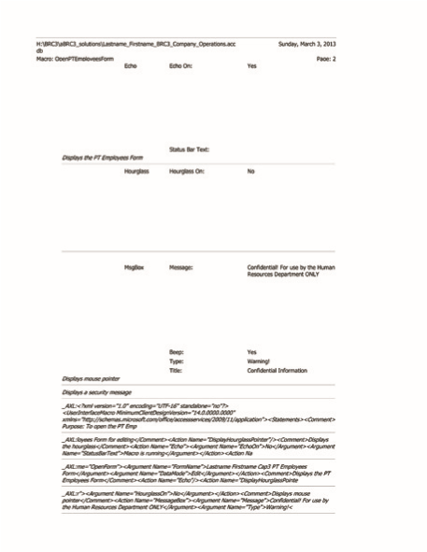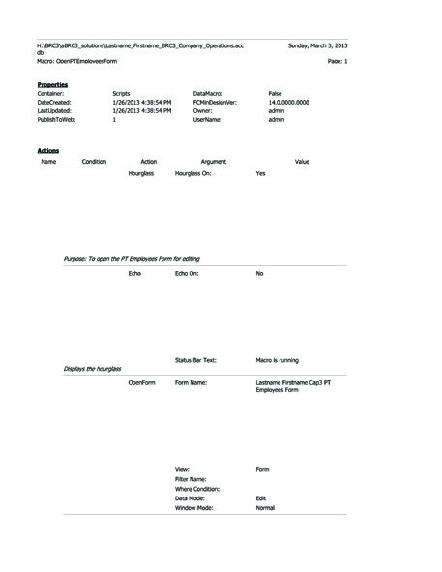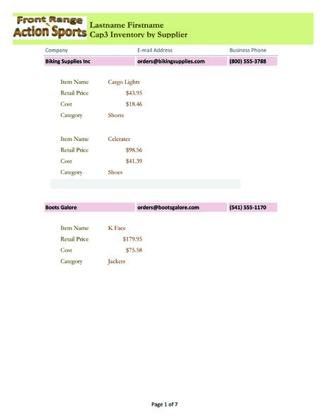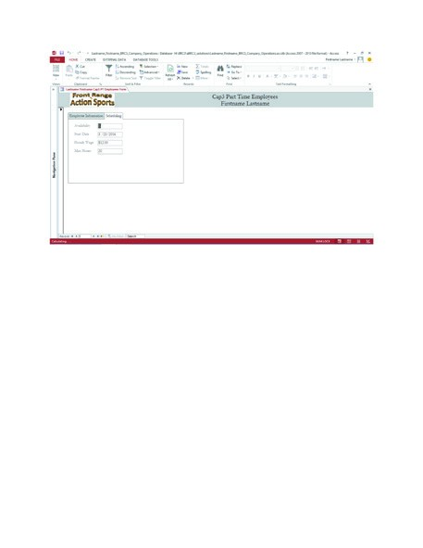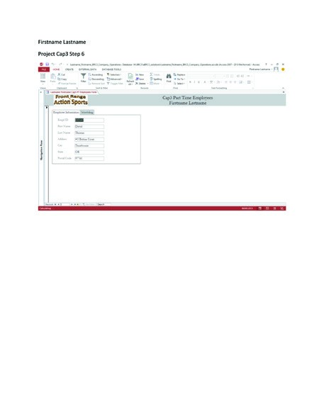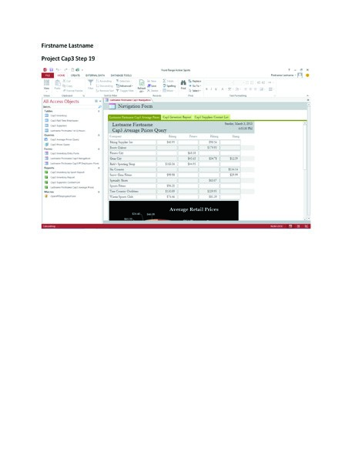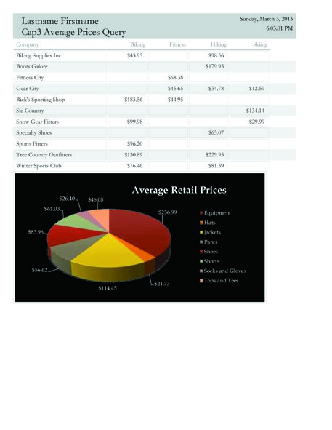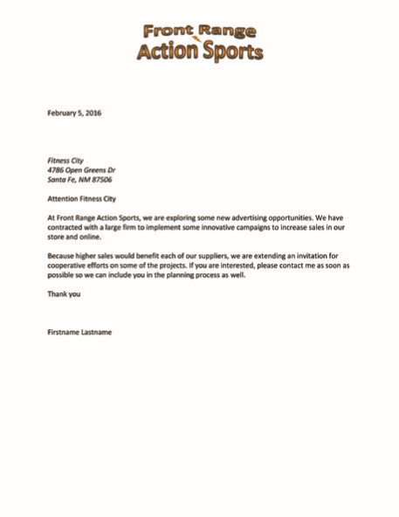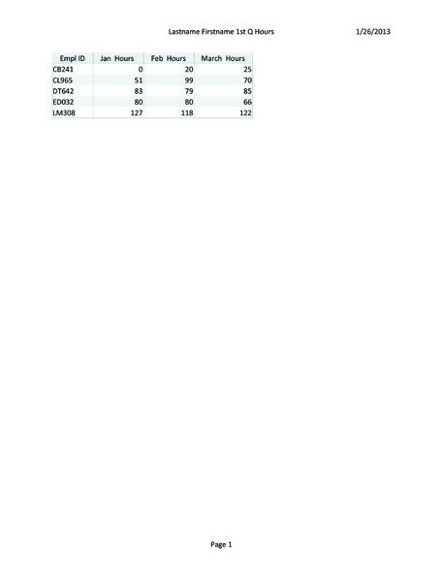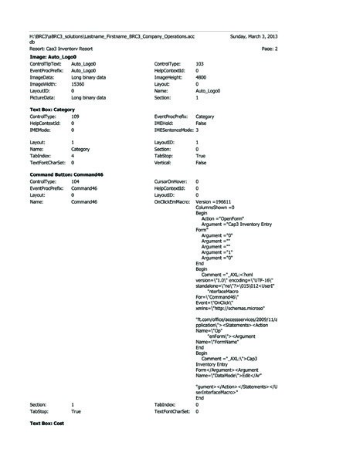

**Figure 3.1** Application Capstone Project 3 Company Operations

1. Start Access. Navigate to the location where the student data files for this textbook are stored.

Locate and open the **aCap3_Company_Operations** database. **Save** the database as **Lastname_ Firstname_Cap3_Company_Operations** in your **Front Range Action Sports** folder. If necessary, enable content.

1. Create a form in **Design** view. Set the **Cap3 Part Time Employees** table as the **Record Source**. Insert a **Tab Control** button at the **0.25-inch mark on the horizontal ruler** and the **0.25-inch mark on the vertical ruler**.
2. Extend the right edge of the **tab control** to the **5-inch mark on the horizontal ruler**. To the **first page** of the **tab control**, using the **Property Sheet**, add a caption of **Employee Information**

From the **field list**, add the **Empl ID**, **Firstname**, **Lastname**, **Address**, **City**, **State**, and **Postal Code** fields at the **1.5-inch mark on the horizontal ruler** and **0.75-inch mark on the vertical ruler**. Apply a **Stacked Layout**, and then resize the text boxes so the right edge aligns with the **3-inch mark on the horizontal ruler**. To the **second page** of the **tab control**, add a caption of **Scheduling** Add the **Availability**, **Start Date**, **Hourly Wage**, and **Max Hours** fields in the same position as those on page 1. Apply a **Stacked Layout**.



, and

. Press

+

**Access**

1. Add a **Logo** in the **Form Header** using **aCap3_Logo**. Resize it to **2 inches wide** and **0.5 inches tall**. Add a **Title** to the **Form Header**. It should display **Cap3 Part Time Employees** on the first line and your **Firstname Lastname** on the second line. **Center** the title in the control.
2. **Save** the form as **Lastname_Firstname_Cap3_PT_Employees_Form** Switch to **Form** view. Enter the following address information for each record, and be sure all information is visible.



|  |  |  |  |  |
| --- | --- | --- | --- | --- |
| **empl iD** | **Address** | **City** | **state** | **ZiP** |
| **CB241** | **241 Ridge Road** | **Redmond** | **OR** | **97756** |
| **CL965** | **400 Deerview Drive** | **Bend** | **OR** | **97701** |
| **DT642** | **#5 Button Court** | **Terrebonne** | **OR** | **97760** |
| **ED032** | **708 Ohmes Road** | **Sisters** | **OR** | **97759** |
| **LM308** | **2010 Frontier Drive** | **Redmond** | **OR** | **97756** |

1. Navigate to **Record 3**. With the first page displayed, press , and then **Close** the dialog box. Open **Word**, and in a blank document, type your first and last names, press then type **Project Cap3 Step 6** Press , **Paste** the screenshot, and then press to move to the next page. Using the same technique, paste a screen capture of the second

page of the form. **Save** this document as **Lastname_Firstname_Cap3 Tabs** If you are instructed to submit this result, create a paper or electronic printout of the document. **Close** the document and **Close** Word. **Close** the form.

1. **Open** the **Navigation Pane**. **Open** the **Cap3 Suppliers Contact List** report in **Design** view. Edit the **Title** of the report to display **Lastname Firstname Cap3 Inventory By Supplier** Your first name and last names should appear on the first line and the rest of the title should appear on the second.
2. Drag the **Page Footer section bar** down to the **2-inch mark on the vertical ruler**. Click the **Subform/Subreport** button. Align the top of the plus (+) sign of the pointer with the **1-inch mark on the horizontal ruler** and the **0.5-inch mark on the vertical ruler**, and then click.
3. Using the **Subreport Wizard**, select the **Cap3 Inventory by Sport** report. Accept other settings, and then type **Lastname Firstname Cap3 Inventory Subreport** as the title of the subreport. Click **Finish**.
   * 1. Right-click in the subreport’s **Report Header**, and click **Report Header/Footer** to remove it from the subreport.

**Project 7–10: Application Capstone Project | Access 683**

* + 1. Delete the **Sport text box control** from the **Sport Header**. Drag the **Detail section bar** up until it meets the **Sport Header section bar**. Delete the controls from the **Sport Footer**, and drag the bottom of the footer area to meet the **Sport Footer section label**.
    2. Delete the **subreport label control**. Reduce the width of the subreport until it reaches the **6-inch mark on the horizontal ruler**. View the subreport in a **New Window**, and resize it to **5 inches wide**. Resize the entire report to **7.5 inches wide.**
    3. Click to select the **subreport**. On the **FORMAT** tab, in the **Control Formatting** group, click **Shape Outline**. Click **Line Type**, and then click the first option for transparent.

1. Switch to **Layout view**. Select the **text box controls** for **Company**, **E-mail Address**, and **Business Phone**. Change the **Shape Fill** to **Red Accent 4, 80% Lighter**, the eighth color in the second row under **Theme Colors**, and the font to **Bold**. **Save** the report. If you are instructed to submit this result, create a paper or electronic printout of the first page of the report.
2. Create a macro to open the **Cap3 PT Employees Form** for editing and display a security message that identifies the information as confidential.



|  |  |  |  |
| --- | --- | --- | --- |
| **Macro Name** | **Action** | **Arguments** | **Comment** |
| OpenPTemployeesForm |  |  | **Purpose: To open the PT Employees Form for editing** |
|  | **DisplayHourglassPointer** | Hourglass On: **Yes** | **Displays the hourglass** |
|  | **Echo** | echo On: **No** status Bar Text: **Macro is executing** |  |
|  | **OpenForm** | Form Name: **Cap3 PT**  **Employees Form**  View: **Form Data**  Mode: **Edit**  Window Mode: **Normal** | **Displays the PT Employees Form** |
|  | **Echo** | echo On: **Yes** |  |
|  | **DisplayHourglassPointer** | Hourglass On: **No** | **Displays mouse pointer** |
|  | **MessageBox** | Message: **Confidential!**  **For use by the Human**  **Resources Department ONLY** Beep: **Yes** Type: **Warning!**  Title: **Confidential Information** | **Displays a security**  **message** |

1. **Save** the macro as **OpenPTEmployeesForm** and **Run** the macro. **Close** the message box, and **Close** the form. **Close** the **Macro Designer**.

Open the **Database Documenter**. In the displayed **Documenter** dialog box, click the **Macros tab**, select the **OpenPTEmployeesForm** macro, and then click the **Options** button. If necessary, clear the **Permissions by User and Group** check box, and then click **OK**. If you are instructed to submit this result, create a paper or electronic printout. **Close Print Preview**.

1. Open the **Cap3 Inventory Report** in **Design** view.
   * 1. Drag the **Page Header section bar** down to the **1-inch mark on the vertical ruler**. Add a button below the title in the **Report Header**. Name the button **Enter Item** Embed a macro to display the **Cap3 Inventory Entry Form** in **Form** view and **Edit Data Mode**. **Close** the **Macro Designer**, updating the property. **Save** and **Close** the report.
     2. Open the **Database Documenter**, and view the object properties for the report. If you are instructed to submit this result, create a paper or electronic printout of page 2 only. **Close Print Preview**.
2. On the **EXTERNAL DATA tab**, in the **Import & Link group**, click the **Excel** button. Locate and open the **aCap3_Hours_Scheduled** file. In the **Get External Data - Excel Spreadsheet**t dialog box, click **OK**. Be certain **Import the source data into a new table in the current database** is selected. Click **OK**. In the **Import Spreadsheet Wizard** dialog box, select the **First Row Contains Column Headings** check box. Click **Next** two times. Choose **Empl ID** as the **primary key**, and then click **Next**. Name the table **Lastname Firstname Cap3 1st Q Hours** and then click **Finish**. In the **Get External Data - Excel Spreadsheet** dialog box, click **Close**. Open the table, and **AutoFit** the columns. If you are instructed to submit this result, create a paper or electronic printout of the table.
3. Open the **Cap3 Suppliers** table. Merge it with the existing Microsoft Word document named **aCap3_Advertising_Letter**. The recipients will be selected from the existing list in the table. **a.** Write your letter by inserting the fields from the table as displayed. Delete the words *Inside Address*, and insert the **Address Block** in its place. Insert the **Company** field after the space following *Attention*. In the closing of the letter, replace *Firstname Lastname* with your **Firstname Lastname**

**b.** **Preview your letters** and **Complete the merge** for **Record 3** only. **Save** the Word document in your **Access Cap3** folder as **Lastname_Firstname_Cap3 Merge** Unless you are required to submit your files electronically, **print** the letter, and then **Exit** Word, closing all documents without saving. **Close** the **Cap3 Suppliers** table.

1. Select the **Cap3 Average Prices Query** and create a new **report**. Switch to **Design** view.
   * 1. Replace the report title with **Lastname Firstname Cap3 Average Prices** and make *Cap3 Average Prices* display on the second line. If necessary, resize the **title control** so both lines are visible. In the **Report Header**, delete the **logo placeholder**.



**Access**

* + 1. Delete the controls in the **Page Footer** and the **Report Footer**. Increase the height of the

**Report Footer** section to the **3-inch mark on the vertical ruler**. Resize the report so it is

**7.25 inches** wide. **Save** the report as **Lastname Firstname Cap3 Average Prices**

**c.** Start Excel. **Open** the **aCap3_Average_Prices** workbook. In the worksheet, select the entire chart. **Copy** the chart to the clipboard. In the **Cap3 Average Prices** report, **Paste** the chart in the **Report Footer**. **Save** the report, and then switch to **Report** view. If you are instructed to submit this result, create a paper or electronic printout. **Close** the report. **Exit** Excel.

1. Create a **Navigation Form** using the **Horizontal Tabs** layout. Add the **Cap3 Average Prices** report, **Cap3 Inventory Report**, and **Cap3 Suppliers Contact List** report to the **Navigation Form**. **Save** the form as **Lastname Firstname Cap3 Navigation** **Close** the form.
2. **Open** the **Access Options** dialog box, and set the following options for the current database only:
   * 1. Set the **Application Title** as **Front Range Action Sports**
     2. Set the **Display form** as **Cap3 Navigation**
     3. Add the **New** and **Quick Print** icons to the **Quick Access Toolbar**.
3. **Close** the database, and then reopen it. Press , and then click the dialog box **Close** button. Open **Word**, and in a blank document, type your first and last names, press , and then type **Project Cap3 Step 19** Press , **Paste** the screenshot, and press . **Save** the document as **Lastname_Firstname_Cap3_Screen** If you are instructed to submit this result, create a paper or electronic printout of the document. **Close** the document and **Close** Word.

**Project 7–10: Application Capstone Project | Access 685**

1. **Close** the database, and then **Exit** Access.
2. As directed by your instructor, submit your database and the paper or electronic printouts of the eight items—three Word documents, one table, two reports, and two document reports—that are the result of this project. Specifically, in this project, using your own name you created the following database and printouts or electronic printouts:



|  |  |
| --- | --- |
| 1. Lastname_Firstname_Cap3_Company_Operations | Database file |
| 2. Lastname_Firstname_Cap3_Tabs | Word document (printed or electronic printout) |
| 3. Lastname Firstname Cap3 Inventory By supplier | Report (p. 1 only) |
| 4. Macro Details | Database Documenter Report (printed or electronic printout) |
| 5. Object Details | Database Documenter Report (printed or electronic printout) |
| 6. Lastname Firstname Cap3 1st Q Hours | Table (printed or electronic printout) |
| 7. Lastname_Firstname_Cap3_Merge | Word document (printed or electronic printout) |
| 8. Lastname Firstname Cap3 Average Prices | Report (printed or electronic printout) |
| 9. Lastname_Firstname_Cap3_screen | Word document (printed or electronic printout) |